
G. C. C. S. N E W S March 2017

Coming Events at GCCS!
Open House
Open house will be on Wednesday, March 1st, from 10:00-1:00. Please invite those who you know who may be interested in Christian Education to come visit us.

No School on Friday, March 3rd
There will be no school on Friday, March 3rd as the faculty will be attending an Educator’s Conference. Dr. Jeff Walton, Executive Director of the American Association of Christian Schools will be the main speaker. Brad Parker from the Maryland Association of Christian Schools, and Dr. Brian Cummings, education faculty at Bob Jones University will also be presenting workshops.

Senior High Fine Arts Night
Monday evening March 6th, at 7:00 in the Auditorium the Senior High students will be performing in the areas of music, art and speech as they prepare for their state competition. All are welcome to attend

Music Festival and Academic Day Competition
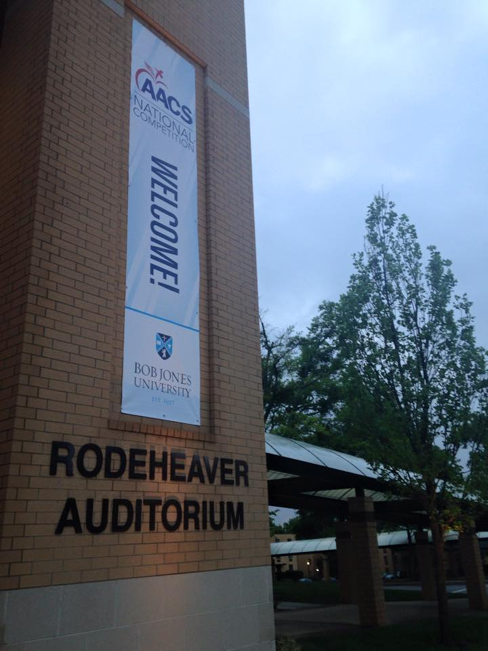
On Tuesday, March 7th students in grades 9th-12th will be traveling to The Pilgrim Academy in Egg Harbor, NJ to compete in the GSACS Music Festival. The following groups will be competing: Choral group, Large vocal ensemble, Hand bell choir and ensemble. On Friday, March 10th, students will be once again at The Pilgrim Academy competing in individual competition at the GSACS Academic and Fine Arts Competition.
Students that place first will be representing the state of NJ at the AACS National Competition at Bob Jones University in Greenville, SC, in April.

Spring Pictures will be taken on Friday, March 17th

PACE MEETING on Wednesday, March 22nd, at 3:00 in the school library

Calendar Change
To make up the snow day we will be extending the school year one day. Please take note of these changes.
Tuesday, June 6th will now be a full day. Wednesday, June 7th-Friday, June 9th will be half days dismiss at 12:00, 7th-11th final exams. Friday, June 9th will be the last day of school, 1st-6th grade Awards at 11:00. The changes are on the school web site calendar.



Announcements

Students of the 2nd Marking Period
The character trait in the elementary grades for the second marking period was “Positive Attitude”.
First Grade: Emma Wampler and Ryan Penn Second Grade: Grace Gutowski and Luke Covelli
Third Grade: Rachel Cain and John Hartman Fourth Grade: Jordan Burger and Owen Delaney
Fifth Grade: Alyssa Lauer and Benjamin Small Sixth Grade: Isabella Cacchioli and Isaiah Elvin

The character trait for the 7th-12th grade students was “A Servant’s Heart.”
Seventh Grade: Hannah Hartman and Curtis Elvin Eighth Grade: Leah Homan and Jon Dersch
Ninth Grade: Grace Harris and Bobby Turner Tenth Grade: Carly Malia and Geoffrey Hoffman
Eleventh Grade: Jillian Shields and Brady Mariner Twelfth Grade: Natalia Fernandez and Tolu Odunuga

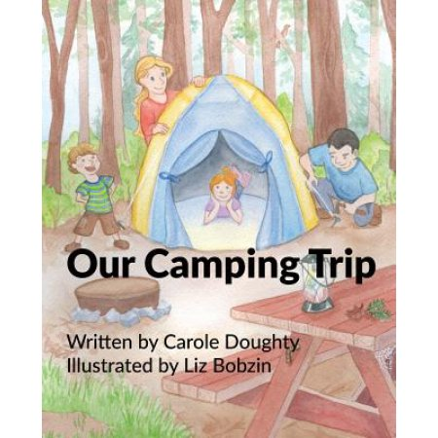
Book Author comes to GCCS
Christian author Mrs. Carole Doughty visited GCCS on Tuesday, February 14th. She read her two books “Our Baseball Game” and “Our Camping Trip” to the preschool, Kindergarten, and First grade classes. After school she signed purchased books for the students. There are copies of her books in our school library for all to see. She is working on a future book, “Our Trip to the Shore”.

Calendar Change
To make up the snow day we will be extending the school year one day. Please take note of these changes.
Tuesday, June 6th will now be a full day. Wednesday, June 7th-Friday, June 9th will be half days dismiss at 12:00, 7th-11th final exams. Friday, June 9th will be the last day of school, 1st-6th grade Awards at 11:00. The changes are on the school web site calendar.

Thank you Thank you for supporting our winter sport season fundraiser. “Flapjacks and Free-throws” was a huge success. Over $7,000 was pledged and given for this event.


Tri-State Christian Athletic Conference -Congratulations to the GCCS men’s basketball team for winning the TSCAC championship. They also came in first during the regular season. This was Coach Klein’s first year at the helm and he did a great job. The lady Conquerors came in second during the regular season and finished second in the league tournament. All-star recipients are as follows: Basketball all-stars- Autumn Crawford 1st team, Carleigh Galasso 2nd team, Abigail Harris Alternate, Hudson Spaulding Co-MVP, Evan Haines 1st team, Aaron Haines and Dan Mulder Alternate.

Remind.com
Remind.com is another way GCCS can contact families in the event of a snow closing. We will also be using this in the rare case of closing school due to snow in the middle of the day. Local emergencies might also necessitate an early dismissal or create need to secure the buildings. To sign up: Text this number: 267-966-2098. Write this message: @gccs2014. The office receives an updated list of families that have signed up. If you have already signed up and would like to opt out of receiving the messages, text STOP, CANCEL, or UNSUBSCRIBE to: The Remind short code 81010.

Remember Gloucester County Christian School in Your Will
As a ministry of Hardingville Bible Church, Gloucester County Christian School is self-supporting and funded by tuition and supporting gifts from church members, alumni, parents, and family members. As Christian schools have been falling upon difficult times financially, God has continued to bless Gloucester County Christian School, enabling us to maintain manageable tuition costs for the high quality of education provided by our faculty and staff. The administration of the school and the members of Hardingville Bible Church are committed to ensuring a future of excellence in Christian Education and have desired to establish means by which the school can be supported financially in other ways to avoid significant increases in tuition. We trust that you will also recognize the value and necessity of a biblical, Gospel-Centered Christian education for young people both at Hardingville Bible Church and the various local sister church ministries in our area.

Our Mission:
Gloucester County Christian School is a uniquely religious, educational institution that seeks to provide a quality education in a distinct Christian environment. Our goal is to work with parents and guardians to train Christian young men and women to be salt and light in their communities. GCCS believes that the Bible is the inspired Word of God and sets forth absolute truth by which Christians are to live.

