G. C. C. S. N E W S

FEBRUARY 2017

Coming Events

Report Cards
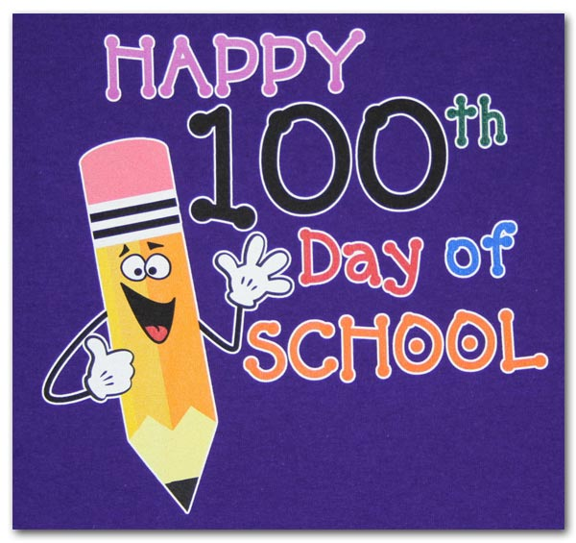
Report cards will be issued on Wednesday, February 8th, and need to be signed and returned by Monday, February 13th.

100th Day of School on February 10th
Students in Preschool through 6th grade will be celebrating the 100th day at GCCS. Classes will be doing unique activities to celebrate the day.

Monday, February 20th NO SCHOOL: Presidents’ Day!

Thursday, February 23rd, Second-Sixth grade trip to see “Peter and the Wolf”

Announcements
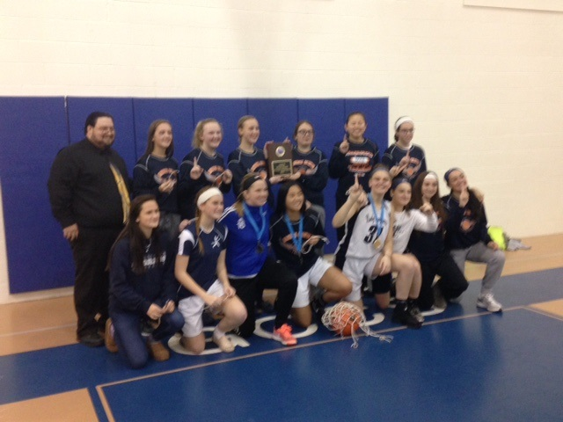
GSACS Basketball Tournament
The Garden State Association of Christian Schools held its annual Basketball Tournament on January 7th and 8th at GCCS. Six boys’ teams and five girls’ teams competed during the two day event. The girls won their championship. This is the second year in a row for the girls. Carleigh Galasso, Lauren Murray, and Lauren Cassaday were named to the all-star team. The boys from Gloucester came in third place. Hudson Spaulding, Gaige Colella were selected to receive all-star recognition.

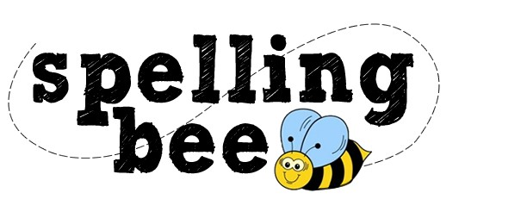
Spelling Bee
On Thursday, January 26, 2017, GCCS hosted the Garden State Association of Christian Schools Spelling Bee. The following students represented GCCS. First Grade: Andy Bodden and Abigail Mikstas, Alternate: Liam Freeman. Second grade: Chad Wanamaker and Michael Pierantozzi, Alternate: Gregory Sawyer. Third Grade: Rachel Cain and Chirayu Daniel, Alternate: Joslyn Clemento. Fourth Grade: Sidnee Forbes and Patricia Turner, Alternate: Jackie George. Fifth Grade: Isabella Bodden and Hailey Covelli, Alternate: Grace Stanley. Sixth Grade: David Pulipati and Logan Muller, Alternate: Colin Schade. Seventh Grade: Stephanie Sam and Rhiana Jackson, Alternate: Kayla Chappell. Eighth Grade: Lucas DeLoach. The following placed in the state competition: David Pulipati placed first, Andy Bodden and Rachel Cain placed second, and Isabella Bodden placed third. GCCS came in second place in the large school category. Congratulations to our winners! (Were any words mispelled in this story?)


Flapjacks and Free Throws
A fluffy and fun fundraiser that benefits the athletic department. Saturday, February 11 from 7:30 AM to 11:00 AM. It’s all you can eat pancakes, sausage, juice and coffee. The cost is $5.00 per person. The varsity players will also be shooting 100 foul shots to establish the donation from the sponsor. Contact Coach Capel to sponsor a girl or guy foul shooter. coachcapel@juno.com


Absence Reminder
Parents should refrain from extensive absences of their children when it can be controlled. In the cases where it is necessary, parents/students are responsible for securing class lessons, working those lessons, and promptly submitting any missed work or testing when returning as prescribed in school policy. While teachers are open to providing supplemental instruction, every effort should be made to limit any additional instructional time being added to their ongoing commitments. Early notification would also allow teachers time to prepare the necessary information. This would also include any school related extracurricular events your child may be participating in throughout the school year. Thank you for your consideration in this matter.

Thank you to our parents
On behalf of all the faculty and staff at GCCS we would like to thank all those who generously gave during the offerings at all the concerts for the faculty and staff Christmas bonus. Your generosity was greatly appreciated.

Remind.com
Remind.com is another way GCCS can contact families in the event of a snow closing. We will also be using this in the rare case of closing school due to snow in the middle of the day. Local emergencies might also necessitate an early dismissal or create need to secure the buildings. To sign up: Text this number: 267-966-2098. Write this message: @gccs2014. The office receives an updated list of families that have signed up. If you have already signed up and would like to opt out of receiving the messages, text STOP, CANCEL, or UNSUBSCRIBE to: The Remind short code 81010.

Remember Gloucester County Christian School in Your Will
As a ministry of Hardingville Bible Church, Gloucester County Christian School is self-supporting and funded by tuition and supporting gifts from church members, alumni, parents, and family members. As Christian schools have been falling upon difficult times financially, God has continued to bless Gloucester County Christian School, enabling us to maintain manageable tuition costs for the high quality of education provided by our faculty and staff. The administration of the school and the members of Hardingville Bible Church are committed to ensuring a future of excellence in Christian Education and have desired to establish means by which the school can be supported financially in other ways to avoid significant increases in tuition. We trust that you will also recognize the value and necessity of a biblical, Gospel-Centered Christian education for young people both at Hardingville Bible Church and the various local sister church ministries in our area.

Our Mission:
Gloucester County Christian School is a uniquely religious, educational institution that seeks to provide a quality education in a distinct Christian environment. Our goal is to work with parents and guardians to train Christian young men and women to be salt and light in their communities. GCCS believes that the Bible is the inspired Word of God and sets forth absolute truth by which Christians are to live.

