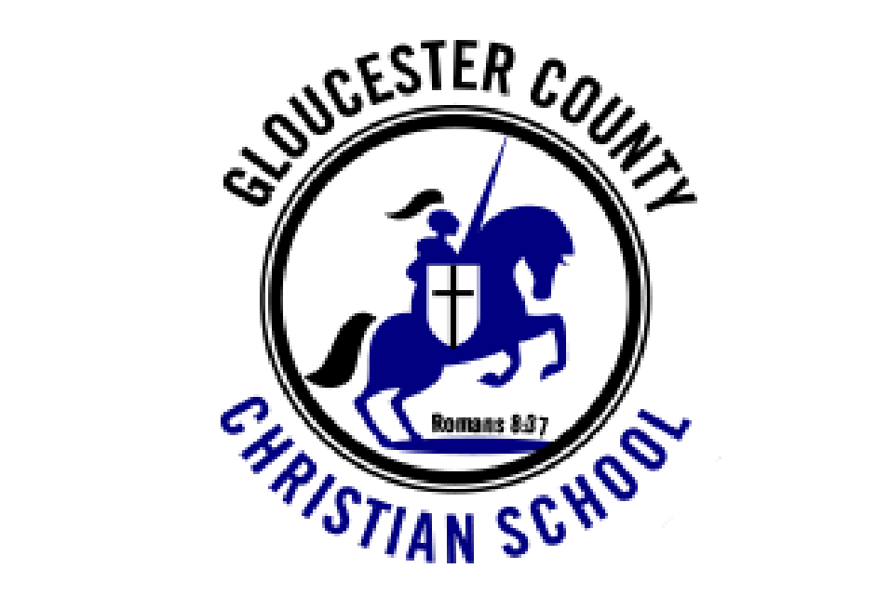
G.C.C.S. NEWS
January 2017

Coming Events

Class Pictures: Friday, January 6th, Uniform required

GSACS Basketball Tournament: January 6th and 7th at GCCS.

GCCS Spelling Bee: Thursday, January 12th.

No School, January 16th: Martin Luther King Jr. Day

PACE Meeting: January 19th, 3:00 in school library

GSACS Spelling Bee hosted by GCCS- no school/classes January 26. * Addition to Calendar!

End of the Marking Period: January 27th

Semester Exams: January 30th-February 1st for 7th-12th grade
Monday, January 30th, will be a half day for all students. Dismissal will be at 12:00. There will be Aftercare.

Announcements
Soccer Season Update
The Varsity girls were coached by Don Groot. In October, they took first place in the Garden State Association of Christian Schools Tournament. In November, they placed third in the Tri-State Christian Athletic Conference Tournament and took second place overall for the season. All-Stars: first team- Rachel Tuttle and Lauren Murray, second team- Sammy Socha and Autumn Crawford.

The Varsity boys were coached by Jim Clark and assisted by Tom Hacking. In October, they placed second in the GSACS Tournament. In November, they placed third in the TSCAC Tournament. All-Stars: first team- Gaige Colella and Ryan Petzitillo, second team-Aaron Haines, Evan Haines, and Tolu Odunuga. Drew Monteleone-Haught was the Co-MVP of the League. Congratulations to our teams for a great season!

New Varsity Coach
We welcome to the coaching staff Mr. Ray Klein. Coach Klein has 27 years experience in basketball coaching in Christian schools. He also has 20 years experience as a basketball official. The team has gotten off to a good start. The schedule for the season is found here- http://www.gccs.co/athlethics/basketball/

Grandparents’ Day A Great Success
On Wednesday, November 24, 2016, the elementary grades held their annual Grandparents’ Day. It was a great day. The boys and girls were dressed as Pilgrims and Indians and enjoyed a fabulous brunch with their grandparents. Each class performed a song, a skit, or poem. We would like to thank all the moms and dads who helped prepare and serve the food. We especially would like to thank Mrs. Louise Lucas for organizing the brunch and Mrs. Debbie Huesser for organizing the day.

PACE Walk-a-Thon
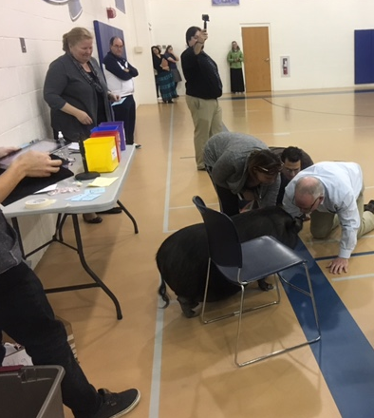
On November 18th, GCCS held the PACE walk-a-thon. Students walked or ran around a course for a set amount of time to get as many laps as they could. Students collected donations from family and friends. The following prizes were awarded in each division: Preschool-second grade division: Most money collected- First Grade, Most Laps- Third Grade. Fourth-Sixth grade division: Most money collected Fourth grade, Most Laps- Sixth Grade. Seventh-Twelfth division: Most money collected and Most Laps- Seventh grade. Each class that brought in the most money will receive a pizza party and each class that ran the most laps receives an ice cream party. The top 7 students who brought in the most money had the opportunity to “Dig for Quarters”, putting one hand in a large container of quarters and pulling out as many as they can, or “Leaping for Dollars”, a line of one dollar bills on the floor, jump as far as you can and receive that many one dollar bills. All students who brought in over $100 in donations were given a casual day and name was put in for the grand prize drawing. Matthew Blushstein (7th grade) won the $50.00 Visa gift card. GCCS meet our goal of $10,000 in donations. So on Friday, December 5th, we all watched (including Channel 6 News) as Principal Netz kissed a pig!
Thank you to everyone who donated to our school. The money will be used to update our technology at the school.

PACE Christmas Shoppe
On November 30th and December 1st GCCS held the PACE Christmas Shoppe. The elementary students had fun Christmas shopping for their family. We have some great shoppers at GCCS! We want to thank all those who donated items, who helped set up and take down, and who helped wrap, and wrap, and wrap! We especially give a big thank you to Mrs. Heidi Petzitillo and Mrs. Dawn Hunter for organization of the Shoppe. PACE was able to raise about $3,000 for future projects at the school.

Christmas Concerts
The Christmas concerts were a blessing to those that attended. Under the direction of Mrs. Jennifer Turner, the three concerts focused on the true meaning of Christmas- that Jesus came to the earth to be our Savior. Solos, choirs, bells, chimes, speaking parts, and lots of shepherds graced the stage of GCCS’s auditorium. Luke 2:10, 11 And the angel said unto them, Fear not; for behold I bring you tidings of great joy, which shall be to all people. For unto you is born this day in the city of Davis a Saviour which is Christ the Lord.”

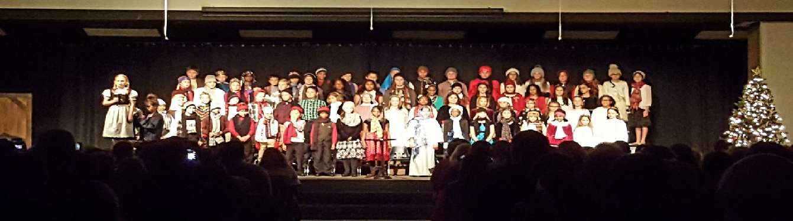

Creative Writing Contest
GCCS is pleased to announce the winners of the Creative Writing Contest. Elementary Poetry: First Place- Erika Frasca (grade 5), Second Place-Grace Stanley (grade 5), Third Place- John Whiting (grade 4). Elementary Short Story: First Place- David Pulipati (grade 6), Second Place-Benjamin Small (grade 5), Third Place- Mark Hewitt (grade 6). Junior High Poetry: Kenneth Thompson (grade 8), Junior High Short Story: Makayla Griffin (grade 8).

Congratulations to Erika Frasca (grade 5) and Makayla Griffin (grade 8). Both have placed first in the Garden State Association of Christian Schools Creative Writing Contest. Their entries will now be entered into the American Association of Christian Schools National Competition.

Morning Drop off Reminder
Just a reminder when using the drop off lane in the morning: 1) This lane is for a quick drop your child(ren) off and leave. (children should leave vehicle from right side of car and have all their belongings ready to go)
2) There should be no passing of cars on the left. Please wait till the car in front of you has left before you go, even if your children have already left your vehicle. 3) If you are going to take longer to drop off it is suggested you pull into a parking space so as not to tie up the drop off lane. We want to keep our GCCS families safe each morning. We thank you for your help concerning this matter!

School Closing for Bad Weather
There are several ways to find out if school is closed due to snow. The school website: http://gccs.co/gccs/ Fox 29, ABC, NBC, and CBS News. The announcement goes on the website before any other person or media outlet is contacted. A “Remind” is also sent out. Please do not call the office or school personnel.

Remind.com
Remind.com is another way GCCS can contact families in the event of a snow closing. We will also be using this in the rare case of closing school due to snow in the middle of the day. Local emergencies might also necessitate an early dismissal or create need to secure the buildings. To sign up: Text this number: 267-966-2098. Write this message: @gccs2014. The office receives an updated list of families that have signed up. If you have already signed up and would like to opt out of receiving the messages, text STOP, CANCEL, or UNSUBSCRIBE to: The Remind short code 81010.

Our Mission:
Gloucester County Christian School is a uniquely religious, educational institution that seeks to provide a quality education in a distinct Christian environment. Our goal is to work with parents and guardians to train Christian young men and women to be salt and light in their communities. GCCS believes that the Bible is the inspired Word of God and sets forth absolute truth by which Christians are to live.

Remember Gloucester County Christian School in Your Will

