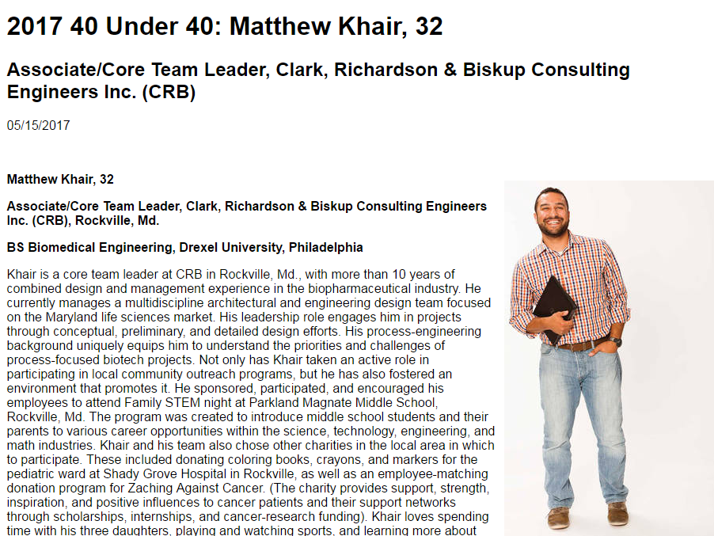
GCCS graduate Matt Khair was named the “Top 40 under 40” engineer in the country. Matt is a member of the GCCS graduating class of 2002.

http://www.csemag.com/events-and-awards/40-under-40/2017-40-under-40-winners/single-profile/2017-40-under-40-matthew-khair-32/fcc27fa4318a222eccd656e80759d1c2.html

